After gathering, accessing, and cleaning the datasets, I did the final visualization and insights. For my visualization, I want to show which dog breeds were tweeted the most. In order to do this, I first had to filter the dataset with only pictures with 80% and higher of confidence that it is that breed of dog on the first prediction try. I feel that the first prediction trial would be the most accurate when compared to the second and third prediction trial. Also, I filtered out the values of “p1” column that did not have capitalized first letter, as I was informed by my Udacity mentor that this eliminates a lot of the values that were not of dog breeds.

Below is the visualization:

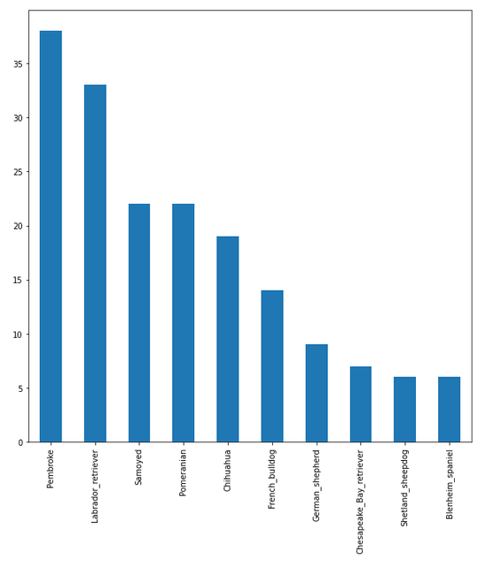

As you can see from the bar chart, the Pembroke was ranked 1st as the dog breed most tweeted about by a good-sized margin. Rank 2nd to 10th were Labrador Retriever, Samoyed, Pomeranian, Chihuahua, French Bull dog, German Shepherd, Chesapeake Bay Retriever, Shetland Shepherd and Blenheim Spaniel.

For my first insight, I wanted to see the top 10 dog breeds that had the most favorite counts on their tweets. Again, I filtered the dataset with only dogs with 80% or high confidence prediction on their pictures and had a capitalized first letter. However, the results this time seemed a bit messy and redundant as there were dog breeds that were repeats within rank 1 through 10 for most favorite counts as shown below.

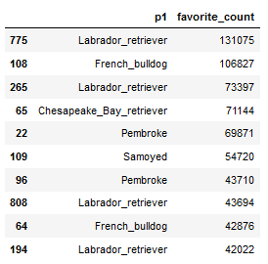

The Labrador Retriever is in 1st, 3rd, 8th and 9th place of most favorite count. While the Pembroke is in 5th and 7th place. French bull dog is in 2nd and 9th place. While the Chesapeake Bay Retriever is in 4th and the Samoyed is in 6th.

While I know what the high ranking Labrador looks like, the Pembroke was very highly ranked in both tweets and favorite count, so I had to research this breed, turns out it is a “Corgi”

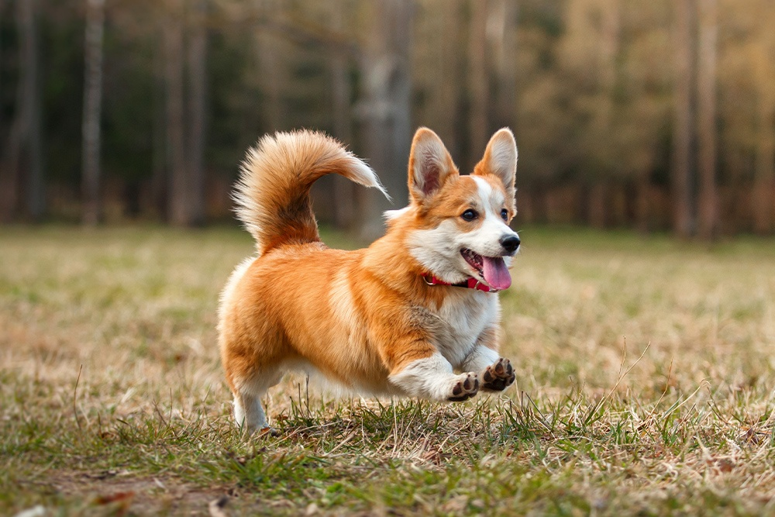

Picture retrieved from: (<https://www.nomnomnow.com/learn/article/pembroke-welsh-corgis-skin-allergies>)

For my second insight, I wanted to see which hour of the day people were most tweeting about dogs. The results are as shown below, with the hours of the day on the left column and tweets made during that hour on the right column:

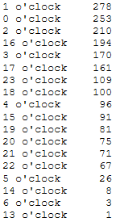

The top 5 were 1am, 12am, 2am, 4pm, and 3pm. It seems people are usually on their phones on Twitter during twilight hours.

For my third insight, I wanted to see the top 10 dog breeds with the highest average rating numerators. Again, I used only the tweets that had an above 80% confidence with “p1” column with only capitalized first letter. The rankings are as shown below.

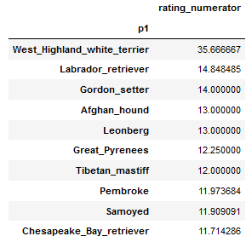

The West Highland White Terrier was overwhelming the 1st place with the highest rating, while 2nd through 10 were close in average rating. There I had to research what the West Highland White Terrier looks like, and it is undoubtedly very cute.

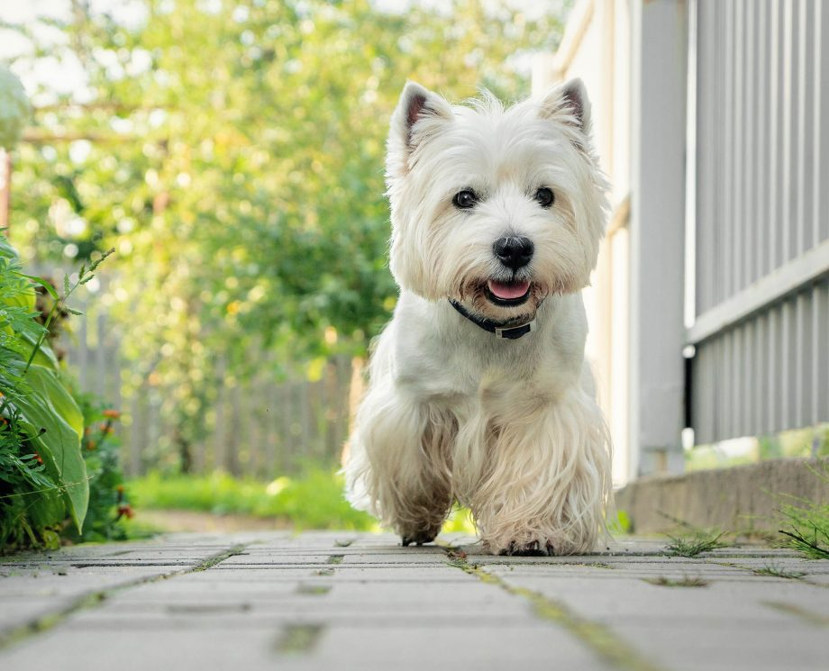

Picture retrieved from: (https://www.countrylife.co.uk/out-and-about/dogs/west-highland-terriers-218716)